YTDS FolderExtension v1.2

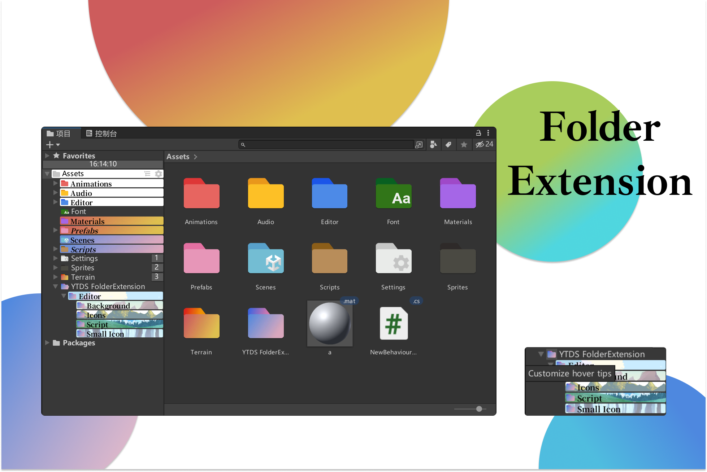

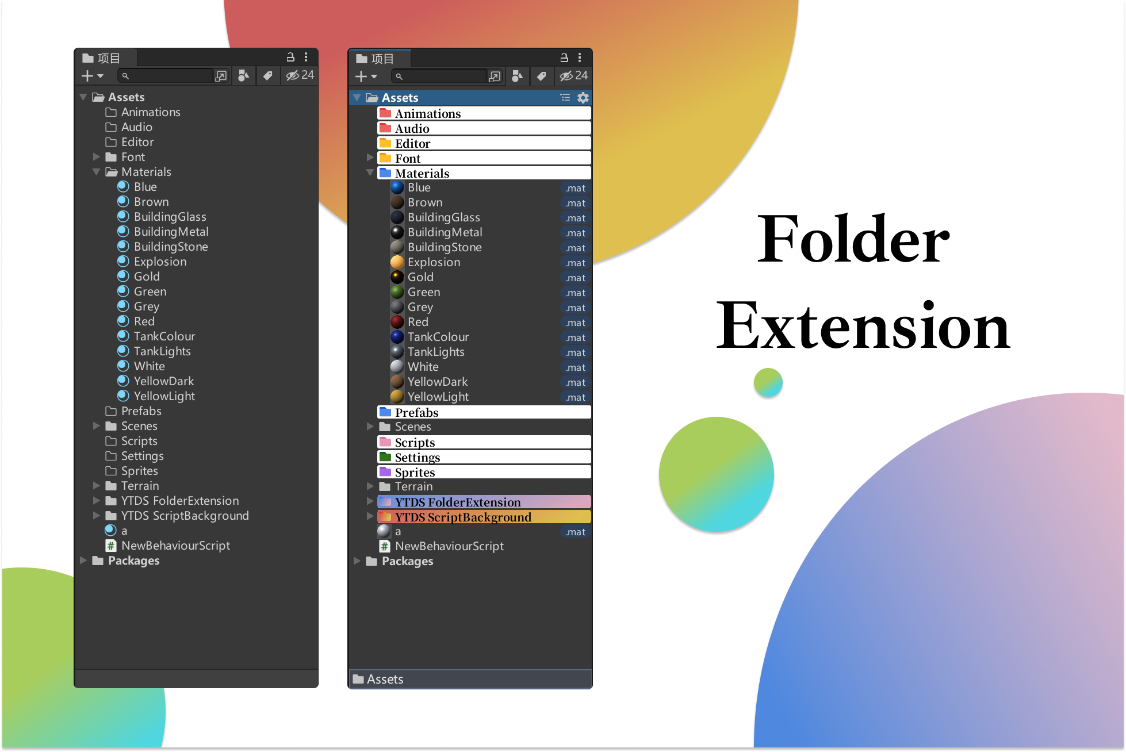

【Instructions for use】

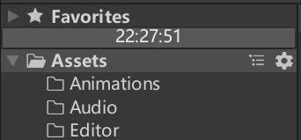After installing the plugin, several new buttons will be added to the Project window.

descript

Time display (appears only in two-column layout)

descriptClick to collapse all folders.

descriptMain settings window



Click the folder icon to enter the folder setting interface.

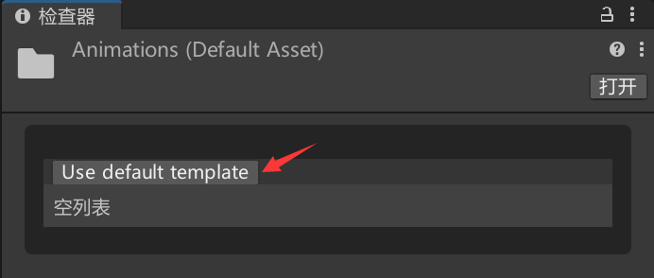

Since it is the first time to use, we have not configured the template, so select "Use Default Template".

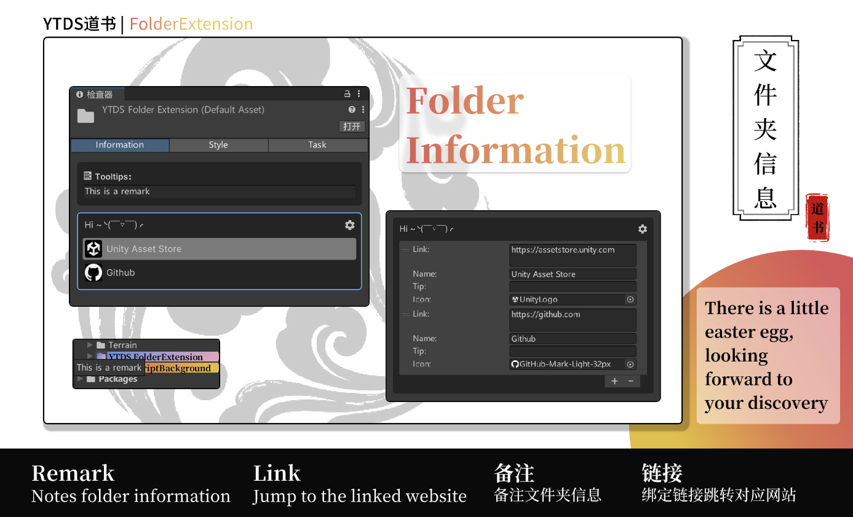

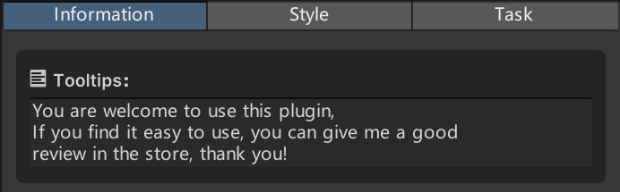

After setting the note information for the folder, hovering over the folder icon will display your note information.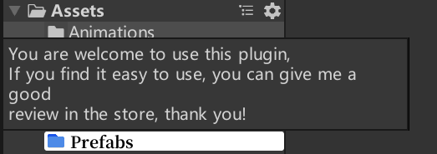

Bind links to folders

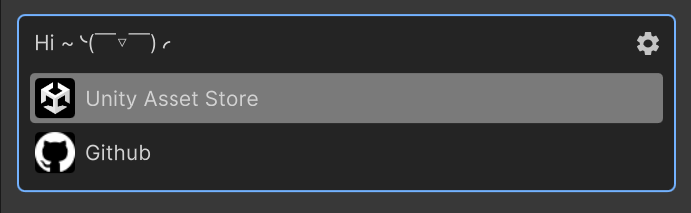

Click to automatically open the browser to enter the webpage.

descript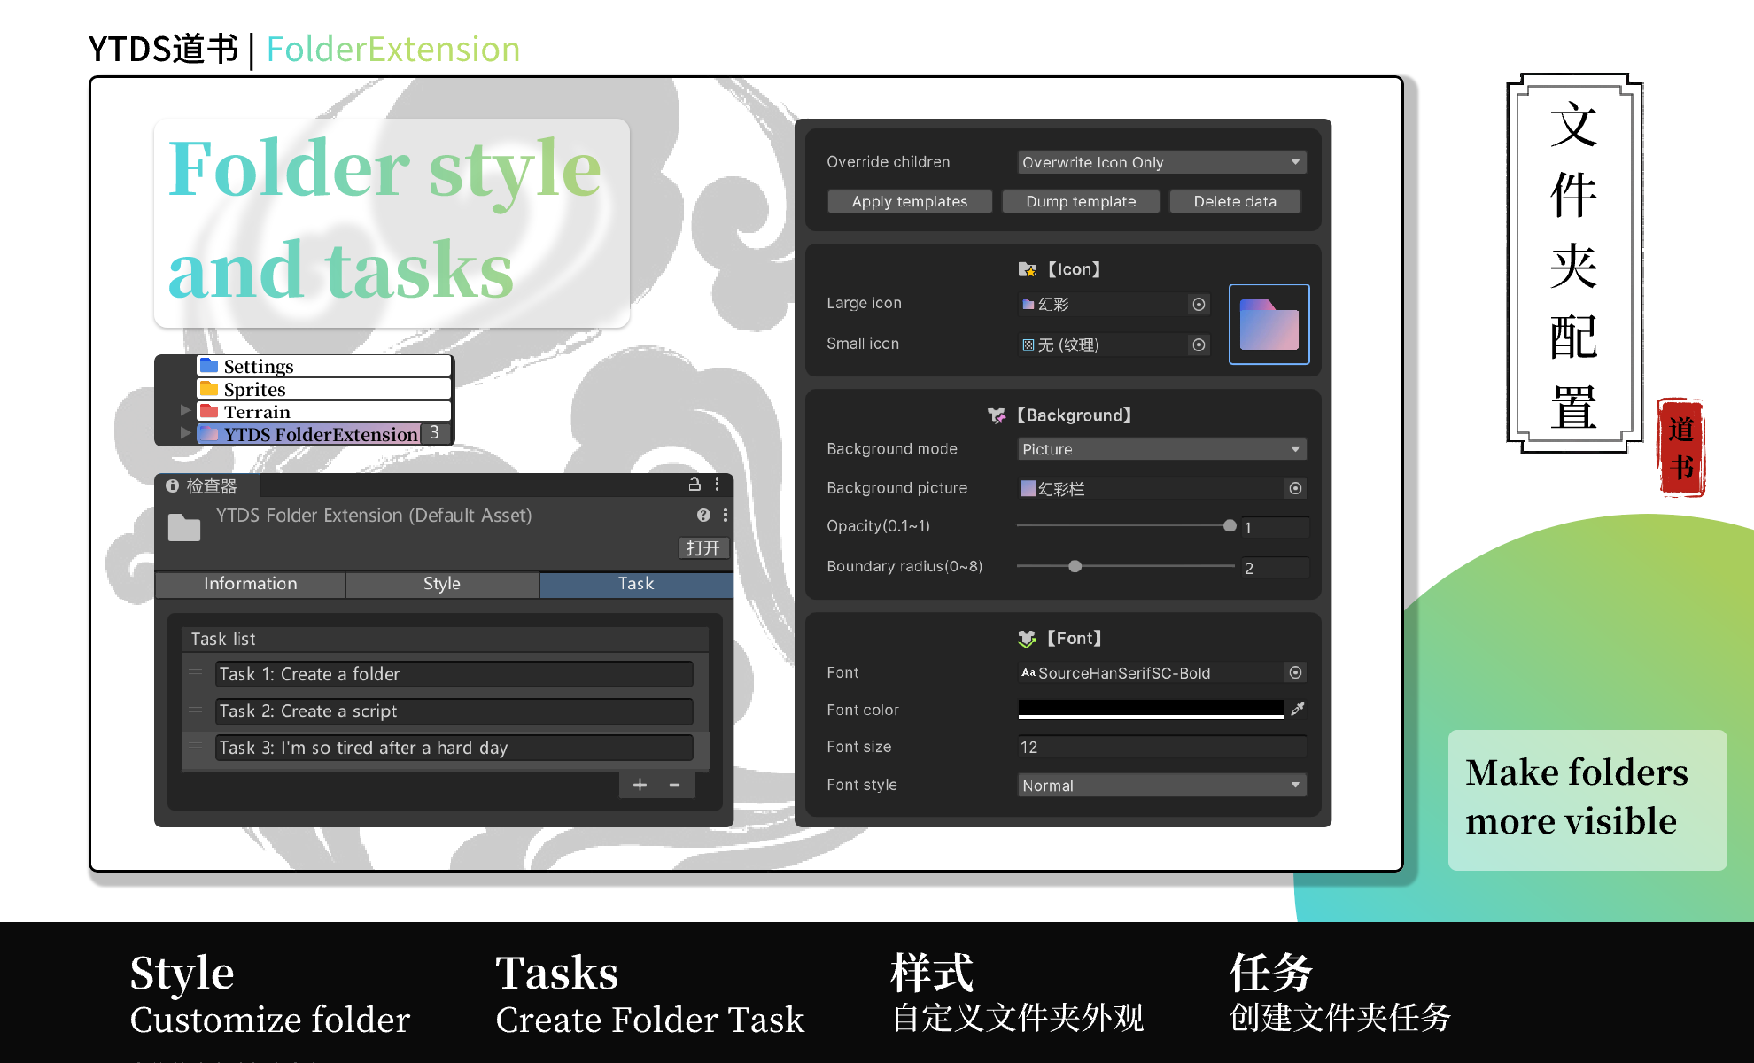

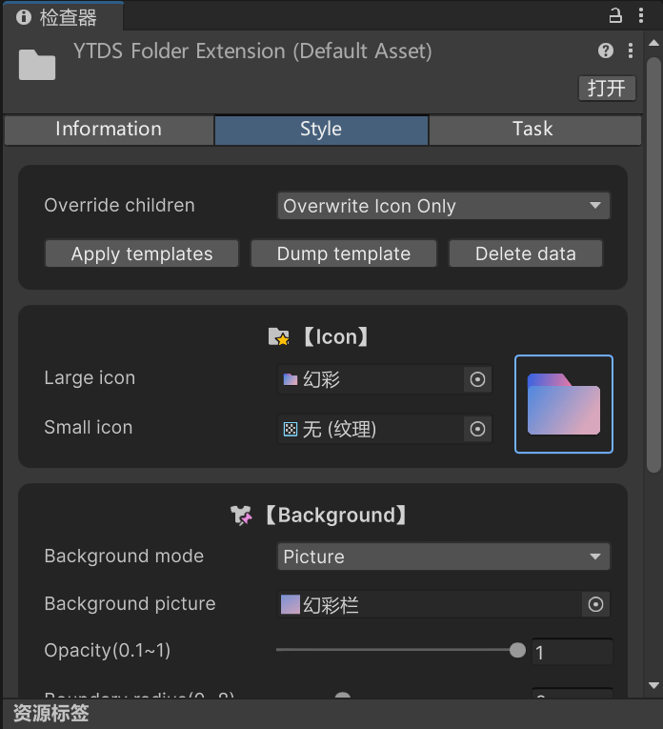

The style page has a wealth of setting options, and you can configure different styles according to your preferences.

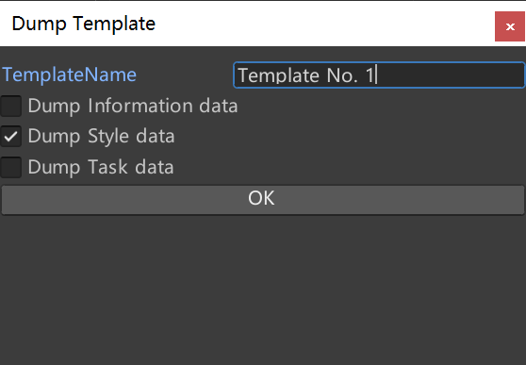

In addition, you can click "Save Template" to save the set parameters as a template.

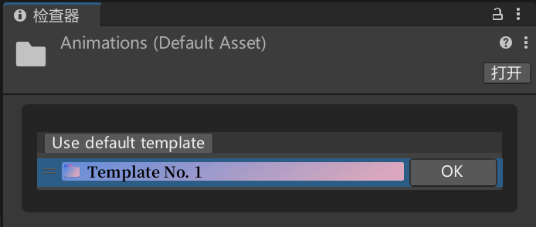This allows you to quickly create appearance styles for other folders as well.

descriptClick Settings to enter the main settings window.

Change the template name to "Editor" and check "Apply this style based on string matching folder"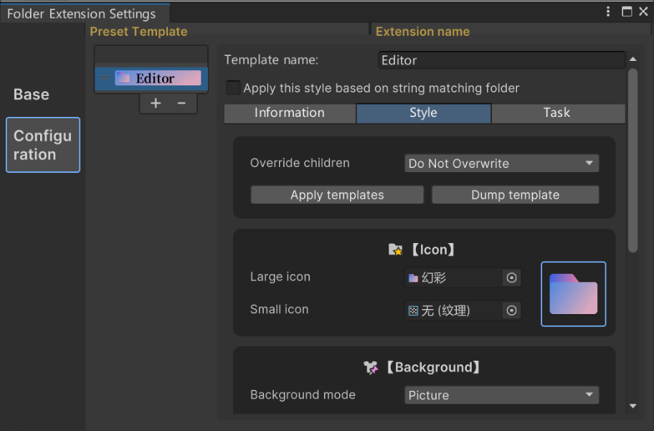.

Currently only supports matching by file name.

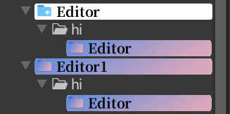The first "Editor" is manually styled, so it won't be overwritten.

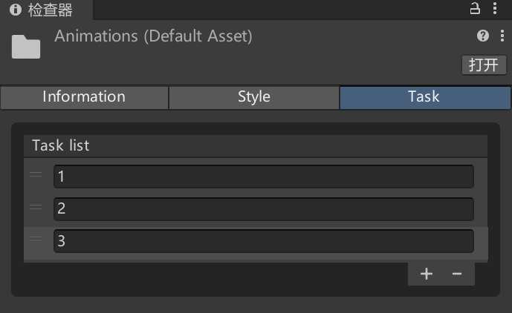

Task creation is also very simple. After the creation is completed, the number of tasks will be displayed in the folder bar.descript

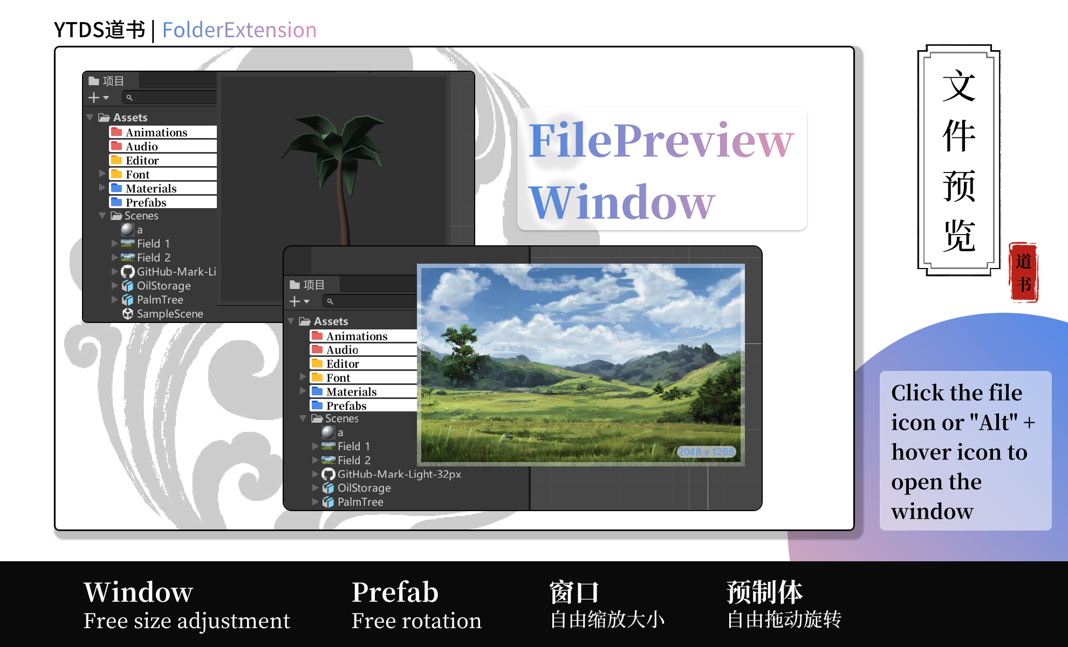



Click the file icon or hold the "Alt" key and hover over the icon to open the preview window.

When the mouse is over the window, slide the mouse wheel to zoom in and out.

Press the mouse wheel to make the window largest or smallest.

(Note: When the window size changes, the window position will be automatically shifted if there is not enough space, which is normal.)

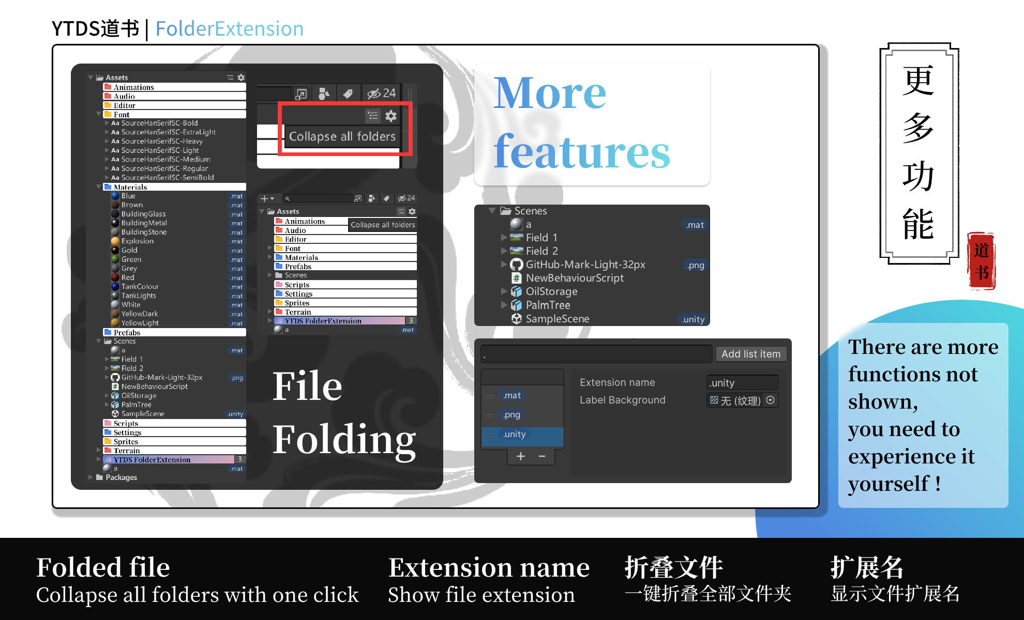

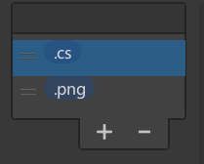descriptClick Settings to enter the main settings window.

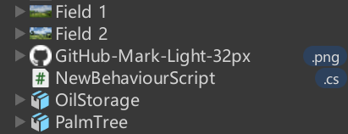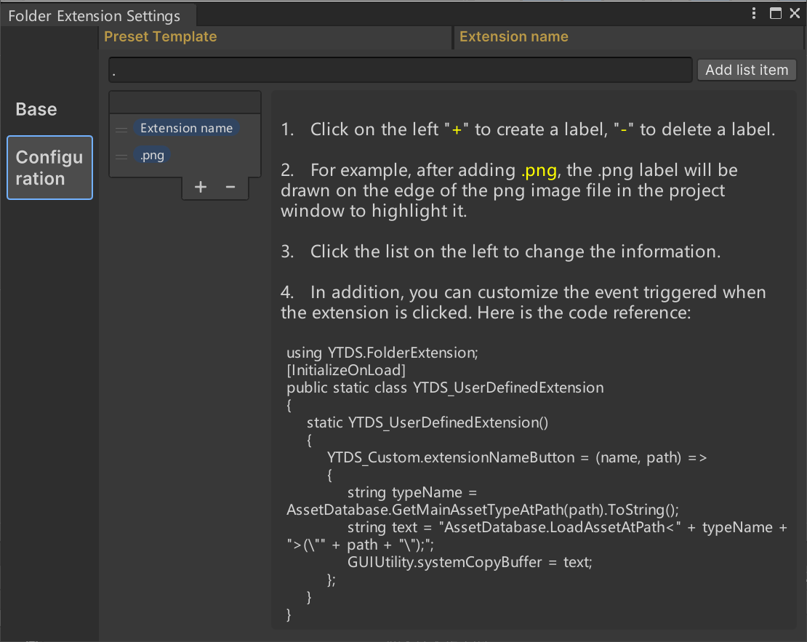Added extension label display.

Additionally, you can create scripts to customize the effect triggered by clicking on the extension tag.

Here is the code reference:

using YTDS.FolderExtension;

[InitializeOnLoad]

public static class YTDS_UserDefinedExtension

{

static YTDS_UserDefinedExtension()

{

YTDS_Custom.extensionNameButton = (name, path) =>

{

string typeName = AssetDatabase.GetMainAssetTypeAtPath(path).ToString();

string text = "AssetDatabase.LoadAssetAtPath<" + typeName + ">(\"" + path + "\");";

GUIUtility.systemCopyBuffer = text;

};

}

}

Thank you for your purchase. If you find it easy to use, please give me a good review on the store interface, so that I will be more motivated, thank you!

YTDS道书